Simple Rectilinear Shapes
# Source: AI Source: Provided by: [Data Path: Persons Table -> ID Column: 1, Name_En Column: Motasem Essam] -> From: [ChatGPT] on [7/25/2026]
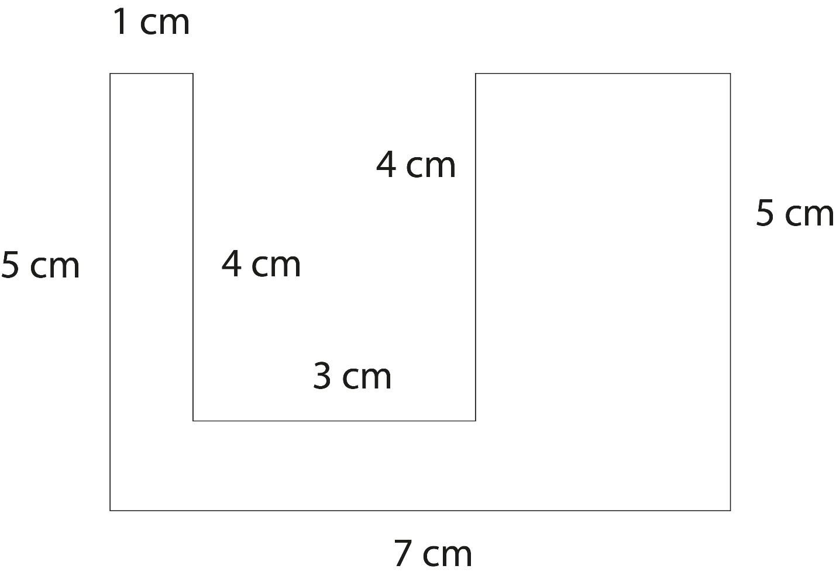
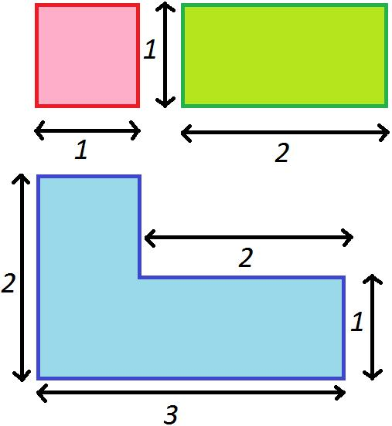
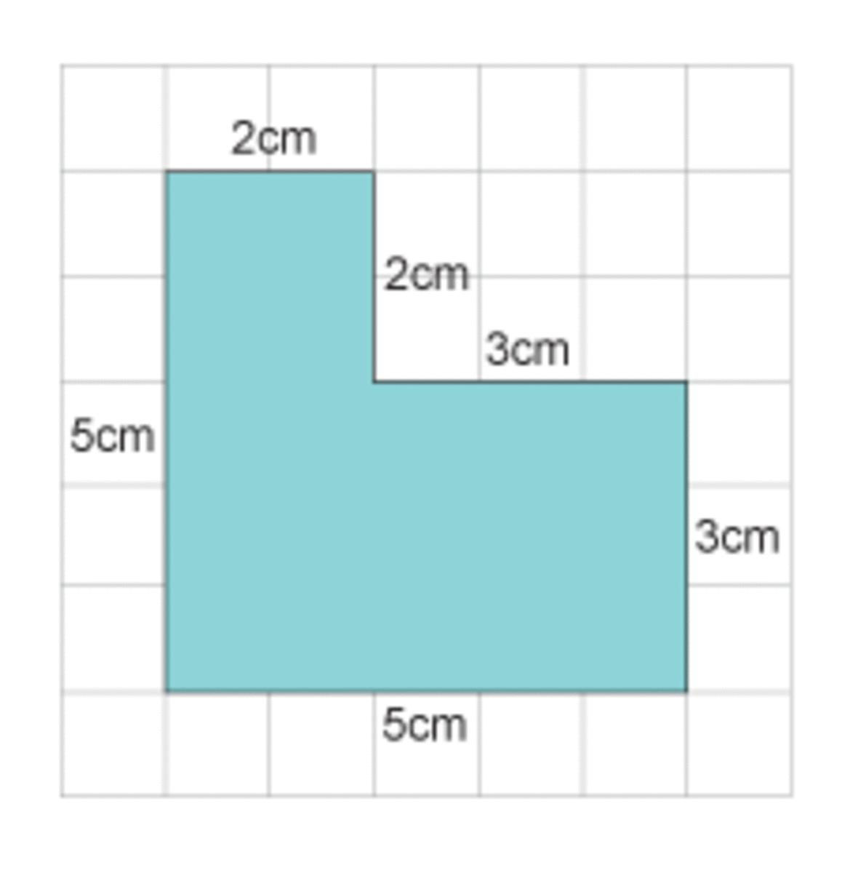
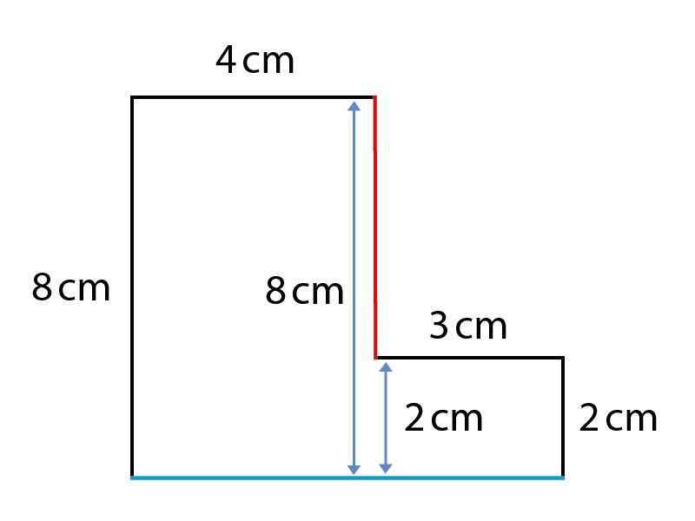

Definition
# Source: AI Source: Provided by: [Data Path: Persons Table -> ID Column: 1, Name_En Column: Motasem Essam] -> From: [ChatGPT] on [7/25/2026]
A Simple Rectilinear Shape is a rectilinear polygon whose boundary consists entirely of straight horizontal and vertical line segments and does not cross or intersect itself.
A simple rectilinear shape therefore satisfies two conditions:
$$\boxed{\text{Rectilinear}}$$
and
$$\boxed{\text{Simple}}$$
Thus:
$$\boxed{\text{Simple Rectilinear Shape}=\text{Rectilinear Shape with a non-self-intersecting boundary}}$$

Fundamental Concept
# Source: AI Source: Provided by: [Data Path: Persons Table -> ID Column: 1, Name_En Column: Motasem Essam] -> From: [ChatGPT] on [7/25/2026]
A simple polygon has a single, non-self-intersecting boundary. Its edges may meet at their shared endpoints, but two nonadjacent edges do not cross.
A rectilinear polygon has edges that are horizontal or vertical.
Combining these properties gives a simple rectilinear polygon.
Example
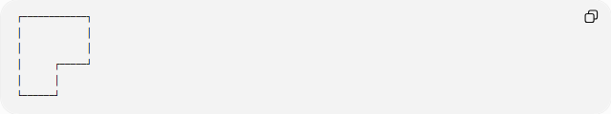
┌────────────┐
│ │
│ │
│ ┌─────┘
│ │
└──────┘
This is simple because its boundary does not cross itself, and it is rectilinear because all edges are horizontal or vertical.

Main Characteristics
# Source: AI Source: Provided by: [Data Path: Persons Table -> ID Column: 1, Name_En Column: Motasem Essam] -> From: [ChatGPT] on [7/25/2026]
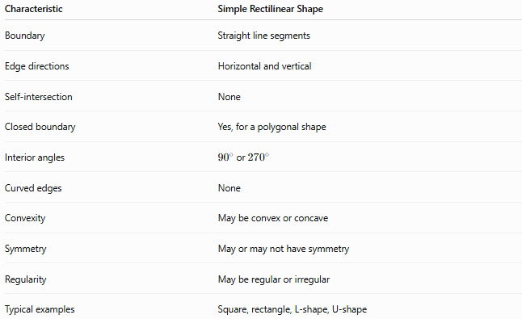
Characteristic | Simple Rectilinear Shape
Boundary | Straight line segments
Edge directions | Horizontal and vertical
Self-intersection | None
Closed boundary | Yes, for a polygonal shape
Interior angles | ${90}^{∘}$or ${270}^{∘}$
Curved edges | None
Convexity | May be convex or concave
Symmetry | May or may not have symmetry
Regularity | May be regular or irregular
Typical examples | Square, rectangle, L-shape, U-shape

Simple vs. Self-Intersecting
# Source: AI Source: Provided by: [Data Path: Persons Table -> ID Column: 1, Name_En Column: Motasem Essam] -> From: [ChatGPT] on [7/25/2026]
The most important characteristic of a simple shape is that its boundary does not cross itself.
Simple Rectilinear Shape
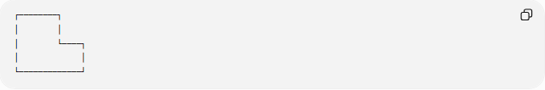
┌────────┐
│ │
│ └────┐
│ │
└─────────────┘
No nonadjacent boundary segments cross.
Self-Intersecting Rectilinear Shape
A self-intersecting boundary can cross itself:
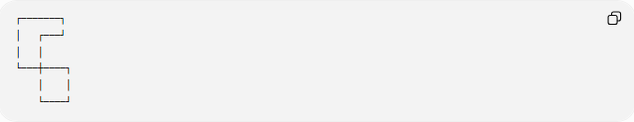
┌───────┐
│ ┌───┘
│ │
└───┼────┐
│ │
└────┘
Such a shape is not simple.

Classification of Simple Rectilinear Shapes
# Source: AI Source: Provided by: [Data Path: Persons Table -> ID Column: 1, Name_En Column: Motasem Essam] -> From: [ChatGPT] on [7/25/2026]
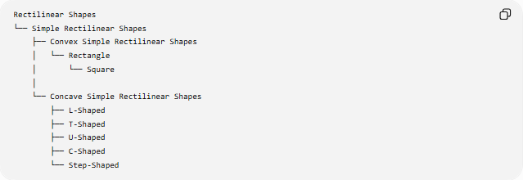
Rectilinear Shapes
└── Simple Rectilinear Shapes
├── Convex Simple Rectilinear Shapes
│ └── Rectangle
│ └── Square
│
└── Concave Simple Rectilinear Shapes
├── L-Shaped
├── T-Shaped
├── U-Shaped
├── C-Shaped
└── Step-Shaped
This classification is based on convexity.
Another classification can be based on regularity:
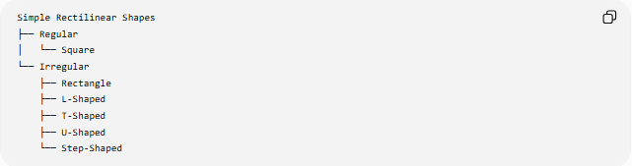
Simple Rectilinear Shapes
├── Regular
│ └── Square
└── Irregular
├── Rectangle
├── L-Shaped
├── T-Shaped
├── U-Shaped
└── Step-Shaped

Convex Simple Rectilinear Shapes
# Source: AI Source: Provided by: [Data Path: Persons Table -> ID Column: 1, Name_En Column: Motasem Essam] -> From: [ChatGPT] on [7/25/2026]
A convex simple rectilinear polygon has no inward indentation.
In the standard polygonal sense, the only convex rectilinear polygon is a rectangle, with the square as a special case.
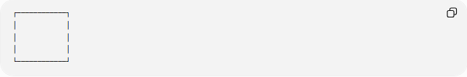
┌────────────┐
│ │
│ │
│ │
└────────────┘
A rectangle is therefore:
$$\boxed{\text{Simple + Rectilinear + Convex}}$$
If all four sides are equal:
$$\boxed{\text{Square}}$$

Concave Simple Rectilinear Shapes
# Source: AI Source: Provided by: [Data Path: Persons Table -> ID Column: 1, Name_En Column: Motasem Essam] -> From: [ChatGPT] on [7/25/2026]
A simple rectilinear polygon can also be concave.
For example:
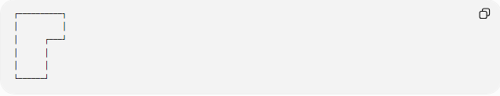
┌──────────┐
│ │
│ ┌───┘
│ │
│ │
└──────┘
The boundary does not cross itself, so it is simple.
However, it contains an inward indentation, so it is concave.
A simple concave rectilinear polygon contains at least one reflex angle:
$$\boxed{{270}^{∘}}$$

Interior Angles
# Source: AI Source: Provided by: [Data Path: Persons Table -> ID Column: 1, Name_En Column: Motasem Essam] -> From: [ChatGPT] on [7/25/2026]
For a simple rectilinear polygon, every interior angle is either:
$$\boxed{{90}^{∘}}$$
or:
$$\boxed{{270}^{∘}}$$
Convex case
All vertices have:
$${90}^{∘}$$
Concave case
At least one vertex has:
$${270}^{∘}$$

Number of Sides
# Source: AI Source: Provided by: [Data Path: Persons Table -> ID Column: 1, Name_En Column: Motasem Essam] -> From: [ChatGPT] on [7/25/2026]
A simple closed rectilinear polygon has an even number of sides:
$$\boxed{n=4,6,8,10,…}$$
The smallest possible simple rectilinear polygon is a quadrilateral:
$$\boxed{n=4}$$
which is a rectangle.
The smallest simple concave rectilinear polygon has:
$$\boxed{n=6}$$
sides.

Interior-Angle Formula
# Source: AI Source: Provided by: [Data Path: Persons Table -> ID Column: 1, Name_En Column: Motasem Essam] -> From: [ChatGPT] on [7/25/2026]
For any simple polygon with $n$sides:
$$\boxed{S=\left(n-2\right){180}^{∘}}$$
This also applies to simple rectilinear polygons.
Example: 6-sided simple rectilinear polygon
$$S=\left(6-2\right){180}^{∘} \\ S={720}^{∘}$$
For an L-shaped polygon:
$$5\left({90}^{∘}\right)+1\left({270}^{∘}\right)={720}^{∘}$$

Convex and Reflex Vertices
# Source: AI Source: Provided by: [Data Path: Persons Table -> ID Column: 1, Name_En Column: Motasem Essam] -> From: [ChatGPT] on [7/25/2026]
For a simple rectilinear polygon:
$$\boxed{C=R+4}$$
where:
- $C$= number of convex vertices
- $R$= number of reflex vertices
Since:
$$n=C+R$$
we also obtain:
$$\boxed{n=2R+4}$$
and:
$$\boxed{R=\frac{n-4}{2}}$$
Example
For an 8-sided simple rectilinear polygon:
$$R=\frac{8-4}{2}=2$$
Therefore:
- $2$reflex vertices
- $6$convex vertices

Area
# Source: AI Source: Provided by: [Data Path: Persons Table -> ID Column: 1, Name_En Column: Motasem Essam] -> From: [ChatGPT] on [7/25/2026]
The area of a simple rectilinear shape can usually be determined by dividing it into rectangles.
Addition
$$\boxed{A=A_{1}+A_{2}+⋯+A_{n}}$$
Subtraction
$$\boxed{A=A_{\text{outer}}-A_{\text{removed}}}$$
This is particularly useful for:
- L-shaped regions
- U-shaped regions
- C-shaped regions
- step-shaped regions

Perimeter
# Source: AI Source: Provided by: [Data Path: Persons Table -> ID Column: 1, Name_En Column: Motasem Essam] -> From: [ChatGPT] on [7/25/2026]
The perimeter is the sum of all boundary segments:
$$\boxed{P=l_{1}+l_{2}+⋯+l_{n}}$$
For a closed rectilinear boundary:
$$\boxed{\text{Total horizontal distance right}=\text{Total horizontal distance left}}$$
and:
$$\boxed{\text{Total vertical distance up}=\text{Total vertical distance down}}$$
These closure relationships are useful for calculating unknown dimensions.

Simple vs. Complex Rectilinear Shapes
# Source: AI Source: Provided by: [Data Path: Persons Table -> ID Column: 1, Name_En Column: Motasem Essam] -> From: [ChatGPT] on [7/25/2026]
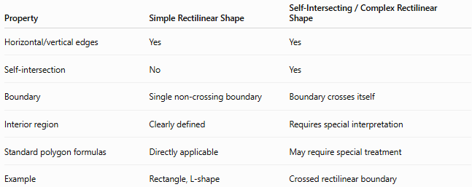
Property | Simple Rectilinear Shape | Self-Intersecting / Complex Rectilinear Shape
Horizontal/vertical edges | Yes | Yes
Self-intersection | No | Yes
Boundary | Single non-crossing boundary | Boundary crosses itself
Interior region | Clearly defined | Requires special interpretation
Standard polygon formulas | Directly applicable | May require special treatment
Example | Rectangle, L-shape | Crossed rectilinear boundary
The mathematically important distinction is simple vs. self-intersecting.
The term “complex shape” is broader and can be used informally, so self-intersecting rectilinear polygon is more precise when describing a crossing boundary.

Simple Rectilinear vs. Irregular Rectilinear
# Source: AI Source: Provided by: [Data Path: Persons Table -> ID Column: 1, Name_En Column: Motasem Essam] -> From: [ChatGPT] on [7/25/2026]
These describe different properties.
Simple Rectilinear
Describes whether the boundary crosses itself:
$$\boxed{\text{No self-intersection}}$$
Irregular Rectilinear
Describes whether the shape is regular:
$$\boxed{\text{Not a regular polygon}}$$
Therefore, a shape can be both:
$$\boxed{\text{Simple + Irregular + Rectilinear}}$$
For example, an L-shape is simple and irregular.
A square is:
$$\boxed{\text{Simple + Regular + Rectilinear}}$$

Simple Rectilinear vs. Convex Rectilinear
# Source: AI Source: Provided by: [Data Path: Persons Table -> ID Column: 1, Name_En Column: Motasem Essam] -> From: [ChatGPT] on [7/25/2026]
These are also different concepts.
Simple
Means:
The boundary does not self-intersect.
Convex
Means:
The shape has no inward indentation.
Therefore, a shape can be:
- simple and convex
- simple and concave
Examples:
$$\boxed{\text{Rectangle}=\text{Simple + Convex + Rectilinear}} \\ \boxed{\text{L-shape}=\text{Simple + Concave + Rectilinear}}$$

Mathematical Classification Tree
# Source: AI Source: Provided by: [Data Path: Persons Table -> ID Column: 1, Name_En Column: Motasem Essam] -> From: [ChatGPT] on [7/25/2026]
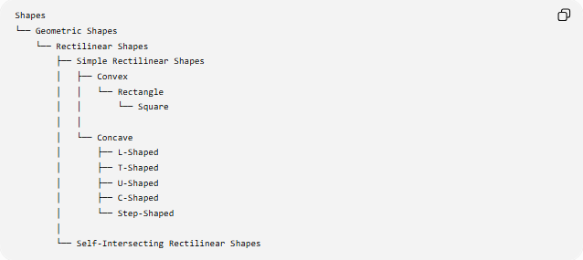
Shapes
└── Geometric Shapes
└── Rectilinear Shapes
├── Simple Rectilinear Shapes
│ ├── Convex
│ │ └── Rectangle
│ │ └── Square
│ │
│ └── Concave
│ ├── L-Shaped
│ ├── T-Shaped
│ ├── U-Shaped
│ ├── C-Shaped
│ └── Step-Shaped
│
└── Self-Intersecting Rectilinear Shapes

Examples

Example 1 — Square
# Source: AI Source: Provided by: [Data Path: Persons Table -> ID Column: 1, Name_En Column: Motasem Essam] -> From: [ChatGPT] on [7/25/2026]
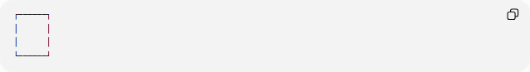
┌──────┐
│ │
│ │
└──────┘
Properties:
$$4\text{ sides} \\ 4\text{ angles of }{90}^{∘}$$
It is simple, rectilinear, convex, and regular.

Example 2 — Rectangle
# Source: AI Source: Provided by: [Data Path: Persons Table -> ID Column: 1, Name_En Column: Motasem Essam] -> From: [ChatGPT] on [7/25/2026]
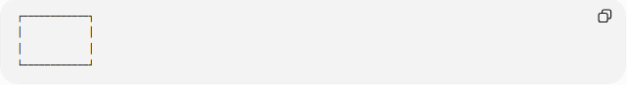
┌────────────┐
│ │
│ │
└────────────┘
It is simple, rectilinear, convex, but a non-square rectangle is irregular.

Example 3 — L-Shape
# Source: AI Source: Provided by: [Data Path: Persons Table -> ID Column: 1, Name_En Column: Motasem Essam] -> From: [ChatGPT] on [7/25/2026]
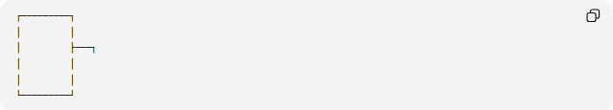
┌─────────┐
│ │
│ ├───┐
│ │
│ │
└─────────┘
It is:
- simple
- rectilinear
- concave
- generally irregular

Key Points
# Source: AI Source: Provided by: [Data Path: Persons Table -> ID Column: 1, Name_En Column: Motasem Essam] -> From: [ChatGPT] on [7/25/2026]
- A Simple Rectilinear Shape has a non-self-intersecting boundary.
- Its boundary consists entirely of horizontal and vertical straight segments.
- A simple rectilinear polygon may be convex or concave.
- A convex simple rectilinear polygon is a rectangle.
- A concave simple rectilinear polygon may be L-shaped, T-shaped, U-shaped, C-shaped, or step-shaped.
- Its interior angles are ${90}^{∘}$or ${270}^{∘}$.
- A simple closed rectilinear polygon has an even number of sides.
- The smallest concave example has 6 sides.
- Simple, convex, and regular describe different geometric properties.

Conclusion
# Source: AI Source: Provided by: [Data Path: Persons Table -> ID Column: 1, Name_En Column: Motasem Essam] -> From: [ChatGPT] on [7/25/2026]
A Simple Rectilinear Shape is a rectilinear polygon whose boundary does not intersect itself. It is one of the fundamental classifications of rectilinear polygons and can be further divided into convex and concave forms.
$$\boxed{\text{Simple Rectilinear Shape}=\text{Non-Self-Intersecting Rectilinear Polygon}}$$

